Assignment 2
Mithilan Thanabalasingam

Task 1: Setting Up a Local Project and Using Github
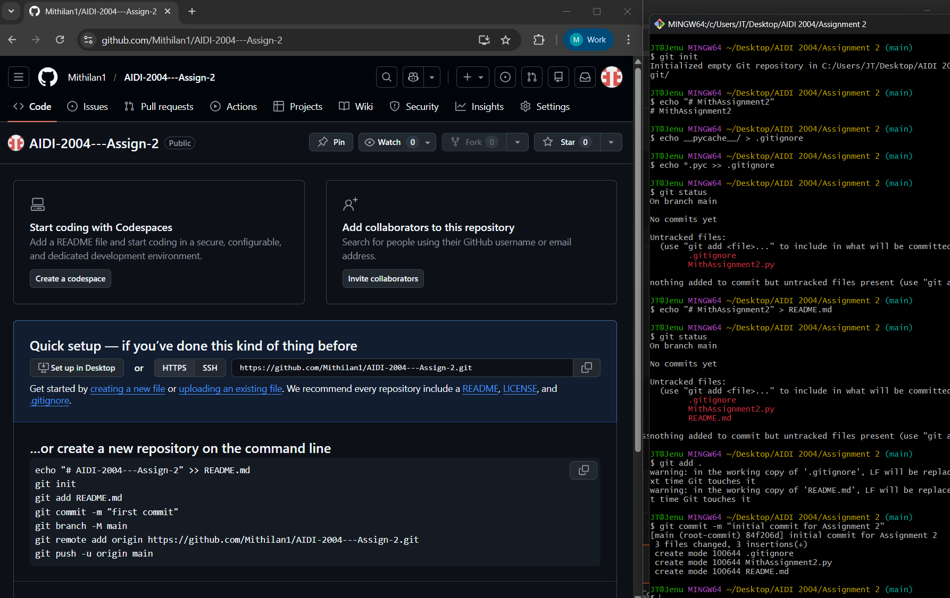

Task 2: Creating a GitHub Action
